WASHINGTON WEEKLY

December 8, 2017

Upcoming Events

Próximos Eventos
December /Diciembre
13 Winter Program – 2:30 pm
Programa de Invierno

13-15 Kids Korner Shoppe
Tienda Korner Shoppe

15 Early Release – 1:30 pm
Salida Temprano

15 Family Movie Night – 6:30 pm
Noche de Película Familiar

20-Jan 1 Winter Break
Vacaciones de Invierno

January / Enero
2 School Resumes
Escuela Resume

5 Early Release – 1:30 pm
Salida Temprano

10 PTO Meeting – 6:30 pm
Junta de Padres

12 Early Release – 1:30 pm

Salida Temprano

15 Martin Luther King, Jr Holiday
No Escuela

19 Early Release – 1:30 pm
Salida Temprano

26 Non-Student Day
Teacher Inservice Day
No Escuela – Día de Entrenamiento para Maestros

February / Febrero
2 Early Release – 1:30 pm
Salida Temprano

6 PTO Meeting – 6:30 pm
Junta de Padres

9 Early Release – 1:30 pm

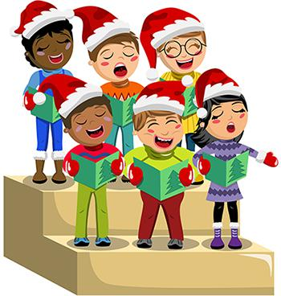
Winter Program
Programa de Invierno
Kindergarten – 3rd Grade
December 13th
2:30 pm – Cafeteria

Kids’ Korner Shoppe coming December 13th, 14th & 15th. Come shop for your family and friends. Flyer on the back of this newsletter.

Tienda Kids’ Korner viene el 13, 14, y 15 de diciembre. Vengan a comprar regalos para sus amigos y familiares. Más información al otro lado de este boletín.

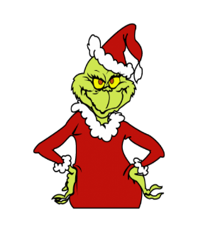
¡Marquen su calendario!

Noche de Película Familiar

THE GRINCH

Friday, December 15th
6:30 pm

Advisory
Have you heard your child talk about advisory? Well, the time has come to begin again! Advisory began today, Friday, December 8th and will take place every Friday morning for a half hour each week. Advisory is an opportunity for your child to be part of a small multi-age group lead by a staff member within our school community. During advisory, your child will build relationships with other members of the group and engage in social-emotional activities. The goals of advisory are for your child to build stronger connections within the school community which, in turn, will positively impact engagement, behavior and attendance.

HOLIDAY DRESS-UP DAY – DECEMBER 15TH
Wear your favorite festive holiday sweater, hat and/or socks.

Vístanse en su favorito suéter, gorra y/o calcetines navideños.
